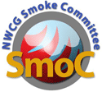
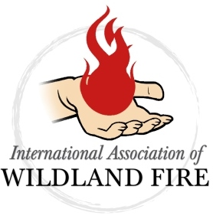
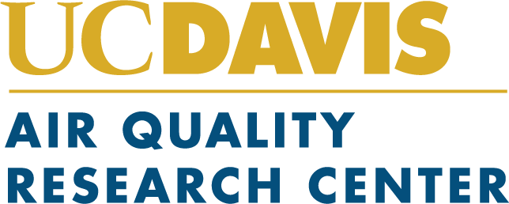

EVENT PROFILE
3rd International Smoke Symposium (ISS3)

Presented by International Association of Wildland Fire
In Partnership with NWCG Smoke Committee & UC Davis Air Quality Research Center

Venues

Sheraton Raleigh Hotel
421 South Salisbury Street
Raleigh, NC 27601
UC Davis Conference Center
550 Alumni Lane
Davis, CA 95616

Date
April 20 -24, 2020
- Monday, April 20 – Workshops
- Tuesday, April 21 – Sessions
- Wednesday, April 22 – Sessions
- Thursday, April 23 – Sessions
- Friday, April 24 – Field Trip
- Program Finalized – January
- March 20 – Room Block Expires (Raleigh)
- April 20-24, 2020 – Symposium

Summary
The symposium will be an international nexus of research, management and policy with a target audience of: governmental air quality regulators (federal, provincial, state, tribal, local); land managers and fire practitioners (federal, provincial, state, tribal, local, NGO and private land owners); research and extension communities (federal, state, academia, students); air quality and fire weather forecasting communities (NOAA, NWS, EPA, Predictive Services, state and local air quality regulatory forecasters); climate change researchers [black carbon, carbon accounting, chemical transport and climate modelers (NASA, EPA, NOAA and academia)], and public health organizations (such as APHA, NAACHO, CSTE, NEHA).

A virtual/hybrid conference will be incorporated as we did at the first ISS and ISS2. We are also adding a second satellite location in California which will focus primarily on health. This allows us to expand our attendance and include individuals who cannot travel to the symposium. This will also allow integration of an online learning component, which will support active connection with our audience year-round. Remote participants will be able to view the presentations live and interact with the presenter, the onsite participants and other remote participants—with the assistance of a facilitator. We anticipate a great response from past attendees as well as a new audience.

Topics will include, but are not limited to:
- Smoke Chemistry and Measurement
- Dispersion and Transport Modeling
- Air Quality Models for Smoke
- Climate Modeling and Climate Change Impacts
- Fire Activity, Emissions, and Emissions Inventories
- Smoke Exposure and Health Effects
- Remote Sensing and Tools for Smoke Management
- Communicating Smoke Impacts
- Smoke Hazard Warning and Monitoring Systems
- Smoke Management and Mitigation
- Human Response to Smoke
- Difference Between Rx Fire and Wildfire in Smoke
- Short/Long Term Tradeoffs Between Rx Fire & Wildfire
- Wildland Fire Smoke Issues in Each Part of the US and Internationally

History/Background
The 1st International Smoke Symposium (ISS) was held in Maryland in 2013 and the 2nd International Smoke Symposium (ISS2) was held November 14-17, 2016 in Long Beach, California.

In 2013 (ISS), 150 people from all different agencies and organization attended the meeting in person, another 75 people attend virtually. Nine countries were represented, including Australia, Austria, Brazil, Canada, China, France, Sudan, UK and United States.

In 2016 (ISS2), 186 people from all different agencies and organization attending the meeting in person, another 97-people attended virtually. Five countries were represented, including Australia, Canada, Poland, UK, and United States.

Past Sponsors and Partners
National Aeronautics and Space Administration (NASA)
Bureau of Land Management (BLM)
California Department of Forestry & Fire Protection (CalFire)
Joint Fire Science Program (JFSP)
U.S. Forest Service Research
US Environmental Protection Agency (EPA)
Sonoma Technology, Inc.
BC Centre for Disease Control
Canadian Forest Service, Natural Resources Canada
Centers for Disease Control and Prevention
Coalition of Prescribed Fire Councils, Inc
Department of the Interior
Desert Research Institute
Michigan Tech Research Institute
Montana Prescribed Fire Services
National Institute of Aerospace
National Park Service
Northwest Fire Science Consortium
Quinault Tribe
Oregon State University
Scion
The Nature Conservancy
University of California

